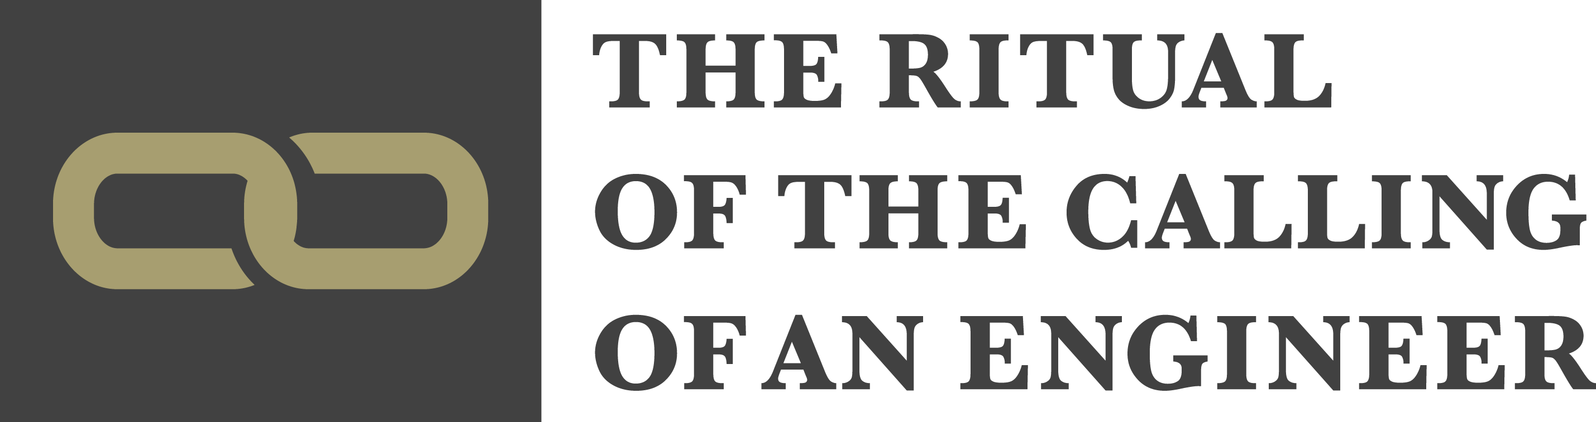

EXTERNAL APPLICANT INSTRUCTIONS
2025 Ceremony – Friday March 21, 2025
(You must attend the iron ring ceremony to receive the iron ring)
Deadline to submit complete application: Friday, January 24, 2025
CONDITIONS & PREREQUISITES FOR APPLICATION PLEASE REVIEW THE FOLLOWING INFORMATION CAREFULLY

The Iron Ring is granted to those whose academic qualifications satisfy the requirements for licensure as a Professional Engineer. The graduates of McMaster University and other accredited Canadian Universities meet the requirements by virtue of graduating from an accredited program of engineering studies. If you do not have an accredited Canadian undergraduate engineering degree you may also be considered for eligibility as an External Applicant, based on your academic qualifications or provincial licensing body membership.

If you do not meet the requirements prescribed herein as PREREQUISITES FOR APPLICATION, your application will be declined automatically, and will NOT be forwarded to the Camp XIII Warden reviewers.

If you do not provide immediate verification of the specific PREREQUISITE requirements noted herein, accompanying your application, your application cannot be appealed after it is declined.

If you do not meet the requirements for the upcoming year’s Ceremony, you may reapply in a subsequent year when you provide the required information/documentation to verify that you meet the noted requirements as detailed here.
Please note that the PEO application process takes some time to complete, plus payment of the P.Eng. license application fee, to obtain a letter from the PEO (if eligible), confirming that:
- your academic credentials qualify you for registration as a P.Eng., or
- you have successfully completed the academic program prescribed by PEO, or
- have had the requirement for completion of the academic program waived
we recommend that you should start the process well in advance of the ceremony.
You must at least CHECK ONE of the prerequisites below, on this page, to proceed to page 5 and apply for the Ritual. Place an ‘X’ in the left column, as applicable.
If you have not checked off at least one of the boxes in the left column below with the required documentation as noted herein, DO NOT PROCEED TO THE NEXT SECTION, and DO NOT SUBMIT AN APPLICATION IN THIS CURRENT YEAR.

Note: No other credentials or qualifications will be considered, except as specified herein.
1. You possess an UNDERGRADUATE degree from a Canadian Engineering Accreditations Board (CEAB) accredited engineering academic program . You must provide a copy of your undergraduate transcripts in English with this Application.
2. You are registered as a P.Eng. with PEO (Professional Engineers of Ontario), or in another Canadian Province or Territory. A photo of your PEO (or alternate Province/Territory) registration license number is required with this Application.
NOTE: Limited Engineering Licence (L.E.L., L.E.T., or similar) does NOT qualify.
If you are a registered PEO, academic transcripts are not required
3. You are registered in another Canadian Province or Territory, outside of Ontario, under the relevant Provincial or Territorial Association of Professional Engineers and Geoscientists, or equivalent, (as applicable). Your Professional registration number and a photo of your registration license number is required with this Application.

4. You are registered as an Engineer in Training/Engineering Intern (EIT) with any Provincial engineering Licensure body in Canada, AND provide with this Application your EIT status card PLUS a confirmation letter from the respective Provincial licensure body, or from PEO (sample letter from PEO attached on pg.4), that you meet the Academic Requirements for Licensure (per PEO Academic Requirements Committee / ARC), consistent with an accredited Canadian engineering program. A PEO (or other Province) EIT card without a letter confirming fulfillment of academic requirements is not sufficient. If you have applied to PEO BEFORE MAY 15, 2023, PEO will assess your academic credentials after you have submitted your application for P.Eng. Licensure. PEO may apply fees to the application process. If you have applied AFTER MAY 15, 2023 the new PEO process will apply. Ref. PEO website: PEO LINK
5. You are a graduate of an engineering program outside of Canada and demonstrate that you have met the academic requirements for licensure for engineers in Canada. You must provide a letter, with this Application, verifying that your academic credentials have been assessed and accepted by PEO Academic Requirements Committee (ARC). (sample letter from PEO attached on pg.4)
If you have applied to PEO BEFORE MAY 15, 2023, PEO will assess your academic credentials after you have submitted your application for P.Eng. Licensure. If you have applied AFTER MAY 15, 2023 the new PEO process will apply. Ref. PEO website: PEO LINK
6. You are a not a graduate of a CEAB accredited Canadian University engineering program and demonstrate that you have met the academic requirements for licensure for engineers in Canada. You must provide a letter, with this Application, verifying that your academic credentials have been assessed and accepted by PEO Academic Requirements Committee (ARC). (sample letter from PEO attached on pg.4). If you have applied to PEO BEFORE MAY 15, 2023, PEO will assess your academic credentials after you have submitted your application for P.Eng. Licensure. If you have applied AFTER MAY 15, 2023 the new PEO process will apply. Ref. PEO website: PEO LINK
7. You are a graduate of an engineering institution outside of Canada and provide a letter from PEO, with this Application, that you have successfully completed the academic program prescribed by the PEO, or have had the requirement for completion of the academic program waived.

After you provide proof with this application of one of the foregoing criteria, in accordance with the box you have checked off in the respective table, you will be contacted with further details, and you will be added to the list of candidates for the March ceremony.
A REMINDER: If you have not checked off and addressed at least one of the Prerequisites above, please do not proceed to the next page, and do not apply in this current year.

APPLICATION MUST BE COMPLETED IN FULL AND ACCOMPANIED BY THE
FOLLOWING OR IT WILL NOT BE ACCEPTED:

1. Copies of the applicant’s undergraduate and graduate transcripts translated into English.
2. Documents verifying that you comply with at least ONE of the Prerequisite requirements detailed on page 2/3 of this Application. Please complete Page 2/3 as applicable.
3. Signatures of two obligated engineers who are willing to sponsor the applicant.
4. Signature of the applicant.
5. Payment made in full by clicking here

Please submit completed application to the Engineering Alumni Office (JHE-A214J) in person, or via email to ironring13@mcmaster.ca

SAMPLE

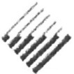
Professional Engineers
Ontario
101-40 Sheppard Ave. W., Toronto, ON M2N 6K9
T: 416-224·1100 800 339-3716 www.peo.on.ca
Enforcement Hotline: 416 224·9528, ext. 1 444

January 19, 2017

TO WHOM THIS MAY CONCERN

To be licensed to practice professional engineering in Ontario, applicants must demonstrate that they possess the necessary academic qualifications, complete PEO’s professional Practice examination (PPE), and have acquired 48 months of satisfactory engineering experience. A minimum of 12 months of the 48-month experience period must be acquired in Canada under the supervision of a licensed professional engineer (P.Eng.) before a license can be granted.

This will confirm that satisfied the PEO’s academic requirements for professional engineering licensure. Accordingly, academic qualifications are deemed to be equivalent to those achieved through the completion of an accredited engineering program at a Canadian university. has also written and passed the PPE. Therefore the requirements remaining for licensure is to satisfy the stipulated work experience requirement.

Once the above-mentioned remaining requirements are satisfied, the application will be presented to the Registrar for consideration to be licensed as a P.Eng. in Ontario.

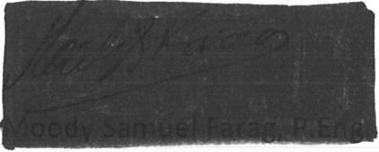
If you require any additional information, please contact the undersigned.
Sincerely,

Manager, Admissions

Association of Professional Engineers of Ontario

FOR OFFICE USE ONLY:
Application No.
Prerequisite Form
PEO Card
Transcripts
Two Sponsors
(Signed & Confirmed)
Application Signature
Application Fee Paid



Camp XIII of the Corporation of the Seven Wardens
Hamilton, Ontario

EXTERNAL APPLICANT FORM
2025 Ceremony - Friday, March 21, 2025
(You must attend the iron ring ceremony to receive the iron ring)

Deadline to submit complete application: Friday, January 24, 2025

I wish to participate in the Ritual of the Calling of an Engineer and submit the following information.

Name:

Street Address: City: Postal Code: E-Mail:
Occupation: Employer:
Residence Telephone: Business Telephone:

Degrees Awarded

1. Degree: Program: Year: University: Country:
2. Degree: Program: Year: University: Country:
3. Degree: Program: Year: University: Country:

Membership in Professional Societies/Associations, such as:
• Professional Engineers of Ontario, or another Province in Canada, or
• in the respective Association of Professional Engineers and Geoscientists in a Canadian Province other than Ontario.
1.

2.

3
Engineering Experience

1.

2.

3.

4.

5.

6.

The following obligated engineers have agreed to sponsor me. An obligated engineer is one who has taken the obligation of the Ritual of the Calling of an Engineer. Please Note: It is mandatory to have two sponsors.

SPONSOR #1

Name: Telephone: Address:
Signature: Year Obligated:

Camp Name/Number:

SPONSOR #2

Name: Telephone: Address:
Signature: Year Obligated: Camp Name/Number:
Date: Applicants Signature:

